FDC demersal shallow carnivore flounders, tiger flathead, Tailor

The diet of juvenile flounder in Swan Bay was almost entirely composed of epibenthic harpacticoids. Juvenile flounder in Port Phillip Bay ate epibenthic harpacticoids, harpacticoid nauplii and gammaridean amphipods.

The observed prey were divided into five groups: crustaceans, molluscs, bryozoa, annelids and other taxa of invertebrates (foraminifers, nematodes, plathelminthes, sea urchins represented only by their spines and very small fishes) (Table 1). Crustaceans were the most important. Among the crustaceans, the isopod Cymodoce truncate had the most important contribution to the diet (% Cn=39.7; followed by the gammarids (% Cn=32.47; % IRI=23.68) and the crabs (% Cn=7.34; % IRI=4.55). Molluscs, bryozoa, annelids and the other prey groups such as sea urchins and plathelminthes, were also consumed but in smaller amounts. Major food groups occurred in the diet of all fish size classes. The food index calculated for each sizes showed that whatever the individual size of wide-eyed flounder, the diet was based

mainly on crustaceans (% IRI=98.83, 98.54 and 97.44 in the juveniles, individuals of medium size and adults, respectively), with no significant differences between them (χ2 test=2.52), followed in decreasing importance by molluscs (% IRI=0.646, 0.562 and 1.027 in the juveniles, individuals of medium size and adults, respectively), bryozoa, annelids and the other prey (Fig. 6, Table 3). Crabs and gammarids were important prey items consumed

by the juveniles class (% N=7.35 and 39.96 respectively), while their numerical abundance decreased for the bigger individuals (% N=4.17 and 30.38 respectively). The latter ingested respectively, counter % N=31.94, 0.88 and 1.10 for the small individuals more isopods Cymodoce truncata, annelids and bryozoa (%N=45.19, 1.65 and 1.74).

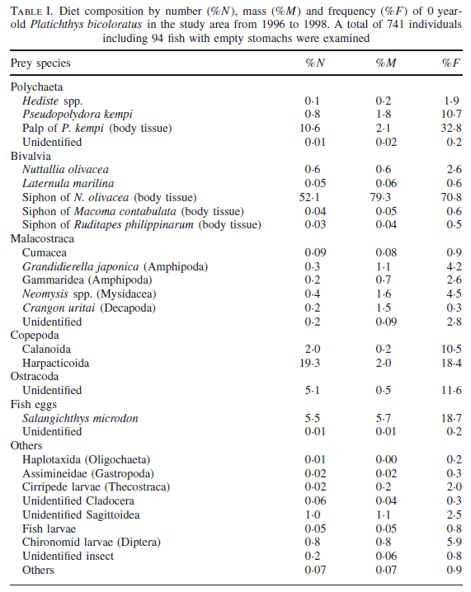

Overall, summer flounder stomach contents from both years showed a consistent shift from crustacean prey to fish prey with increasing predator length (Figure 2). Mysid shrimp

were the dominant prey item (contributing up to 86% of the diet by weight) for small summer flounder, whereas larger individuals had diverse diets that included greater percentages of bay anchovy, weakfish, spot, and other fishes. Fish prey (mostly bay anchovy) comprised a greater proportion of the diet in 2006 than in 2007 by an average of 21% (range = 7–40%) for

each month and size-class but most notably for medium-sized summer flounder (Figure 2). The contributions of individual prey species to the diets varied by month. For example, sevenspine bay shrimp were particularly important in the diets of medium-sized summer flounder in late winter and spring (March and May), whereas mysid shrimp increased in the diets of medium-sized summer flounder during summer and fall.

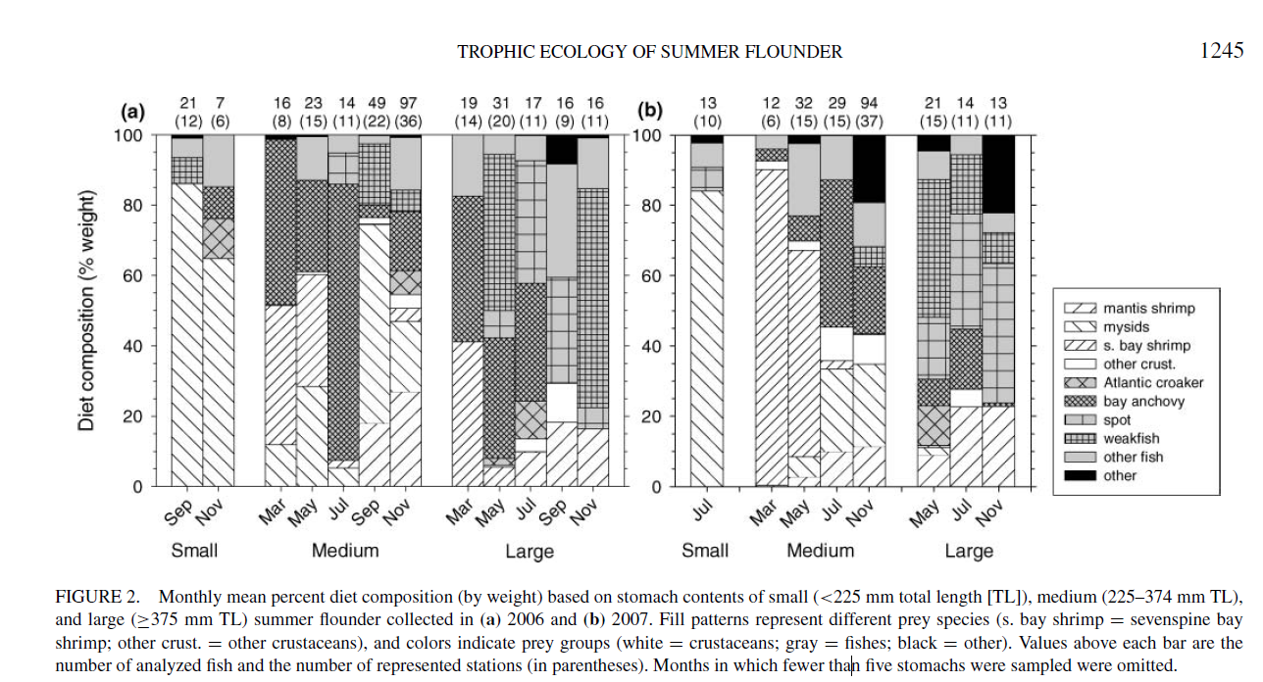

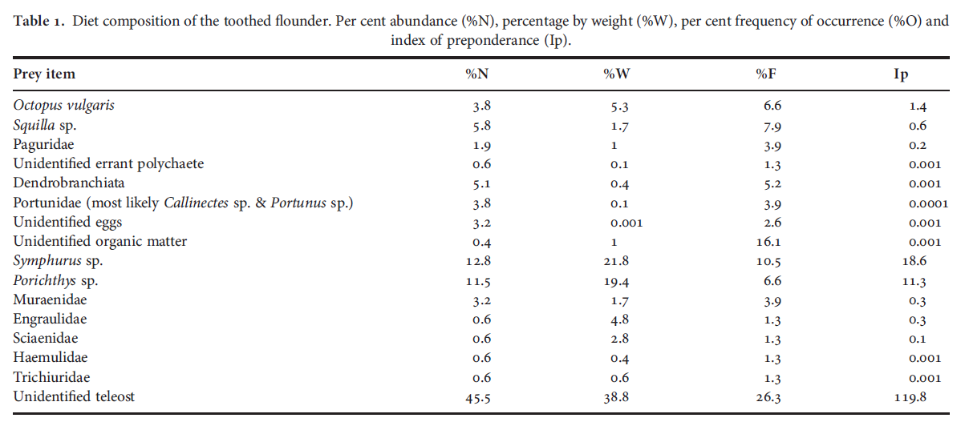

In total, 294 prey items, belonging to 14 taxa, were identified, plus unidentified eggs and unidentified organic matter. Fish were the most frequent (%F ¼ 52.5), abundant (%N ¼ 75.4), had the highest biomass (%W ¼ 90.3) and the highest values of the Ip. Of the identified fish, the most important prey were the tonguefish *(Symphurus* sp.), which also predominated in terms of percentage by weight, frequency of occurrence and abundance, followed by the midshipman (*Porichthys* sp.) and moray eels (Muraenidae). Other fish prey of the families Engraulidae, Sciaenidae, Trichiuridae and Haemulidae were occasionally recorded. Of the invertebrates, the most important prey according to the all indices and the Ip, was the common octopus (Octopus vulgaris), although its importance was much lower that that of the fish. The mantis shrimp (Squilla sp.) was also a quite important prey item; its importance was higher that that of some fish. The remaining invertebrates (hermit

crabs, shrimps, polychaetes and swimming crabs) showed very low values of all indices and the Ip and were recorded only occasionally.

**Young tailor**, up to about 30 cm, feed on small bait fish (such as whitebait) and crustaceans. They’re sometimes called ‘choppers’ for the way they bite prey into pieces before eating it. Usually, the tail is bitten off first to disable the prey, with the remains eaten by others in the school. Feeding frenzies on schools of baitfish have been seen close to shore.

**Adult tailor** prey on sea mullet, yellow-eye mullet, whiting, garfish, mulies and blue mackerel. They also eat other tailor, if small or injured.

juveniles 1,2,3

|  |  |
| --- | --- |
| **prey item** | **probability of consuming** |
| ZMI Microzooplankton | 0.2 |
| ZME zooplankton | 0.2 |
| SAR sardines | 0.1 |

small 4,5

|  |  |
| --- | --- |
| **prey item** | **probability of consuming** |
| BC polychaetes | 0.1 |
| BD echinoderms | 0.1 |
| MAZ Macrozoobenthos | 0.2 |
| BG benthic grazer | 0.1 |
| BFF mussels, scallops oysters | 0.1 |
| ZME zooplankton | 0.2 |
| SAR sardines | 0.1 |

medium 6,7

|  |  |
| --- | --- |
| **prey item** | **probability of consuming** |
| BC polychaetes | 0.1 |
| BD echinoderms | 0.1 |
| MAZ Macrozoobenthos | 0.2 |
| BG benthic grazer | 0.2 |
| BFF mussels, scallops oysters | 0.2 |
| ZME zooplankton | 0.1 |
| SAR sardines | 0.1 |
| FDC | 0.05 |
| FDC | 0.05 |
| FSR small reef fish | 0.05 |
| FLR large reef fish (small, juveniles of these) | 0.05 |

large 8,9,10

|  |  |
| --- | --- |
| **prey item** | **probability of consuming** |
| BC polychaetes | 0.05 |
| BD echinoderms | 0.1 |
| MAZ Macrozoobenthos | 0.1 |
| BG benthic grazer | 0.1 |
| BFF mussels, scallops oysters | 0.1 |
| ZME zooplankton | 0.05 |
| SAR sardines | 0.2 |
| FDC | 0.2 |
| FSR small reef fish | 0.1 |
| FLR large reef fish (small, juveniles of these) | 0.1 |

**Flathead:** Out of 581 stomachs of *G. suppositus* (total length: 143-280 mm) analysed, a total of 21 prey types were identified. Crustaceans (%IRI= 86.9) and fishes (%IRI=12.9) were the most important food categories of *G. suppositus.* Molluscs, sea urchins and detritus were insignificant in the diet. Among the crustaceans, %IRI values for benthic crabs (39.6) and *S. choprai* (31.8) were higher. Penaeid prawns (8.1) and *A. indicus* (5.1) were the next in dominance among the crustaceans. Penaeid prawns such as *Metapenaeus* spp, *Trachypenaeus* spp and other crustaceans like *Hippa* spp and *Oratosquilla nepa* were also present. Among the fishes, unidentified fishes (11.8) were dominant followed by *N. mesoprion*, *G. suppositus*, *Saurida* spp, *Trichiurus* spp, *Cynoglossus macrostomus*, *Stolephorus* spp and *Leiognathus bindus*.

References

[Spatial variation in feeding, prey distribution and food limitation of juvenile flounder Rhombosolea tapirina Gunther.1987.](http://apps.webofknowledge.com/full_record.do?product=UA&search_mode=GeneralSearch&qid=1&SID=X2UT1jczAgkzwJYDfL5&page=1&doc=6) Shaw, M; Jenkins, GP. Journal of Experimental Marine Biology and Ecology  volume: 165   issue: 1   pages: 1-21

Diet composition and feeding habits of the wide-eyed flounder, *Bothus podas*, in the Gulf of Gabes (Tunisia). Souhir Abid & Amira Ouannes-Ghorbel & Othman Jarboui & Abderrahman Bouain Mar Biodiv (2013) 43:149–161

Seasonal and ontogenetic diet shift in juvenile stone flounder *Platichthys bicoloratus.* T. Tomiyama. *Journal of Fish Biology* (2012) 81, 1430–1435

Andre Buchheister & Robert J. Latour (2011) Trophic Ecology of Summer Flounder in Lower Chesapeake

Bay Inferred from Stomach Content and Stable Isotope Analyses, Transactions of the American Fisheries Society, 140:5,

1240-1254, DOI: 10.1080/00028487.2011.618364

Feeding habits of the toothed flounder *Cyclopsetta querna* (Paralichthyidae) of the

south-east Gulf of California Felipe Amezcua, Alfonso Portillo2 and Felipe Amezcua-Linares Journal of the Marine Biological Association of the United Kingdom, 2011, 91(6), 1225–1230

K.P. Abdurahiman, P.U. Zacharia, T. H. Nayak and K.S. Mohamed. Trophodynamics of the Spotfin Flathead *Grammoplites suppositus* (Troschel 1840) from the Southeast Arabian Sea. *Asian Fisheries Science* 20(2007):125-143

http://www.fish.wa.gov.au/Species/Tailor/Pages/default.aspx